**EER DIAGRAM**

**MUSIC PLAYER DATABASE**

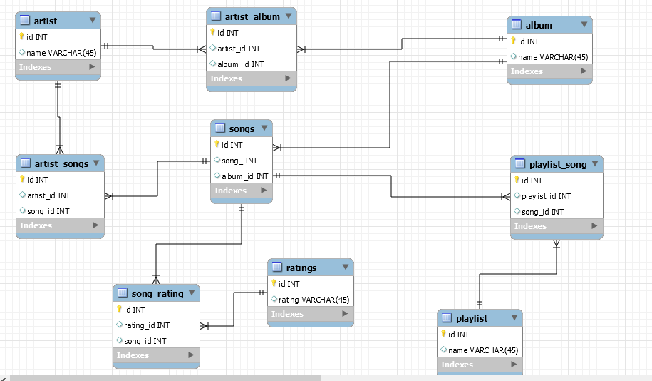

**SCHOOL DATABASE**

